**Question-1 Using STL Array gets and sets a reference to an element based on a given index.**

**Ans.**

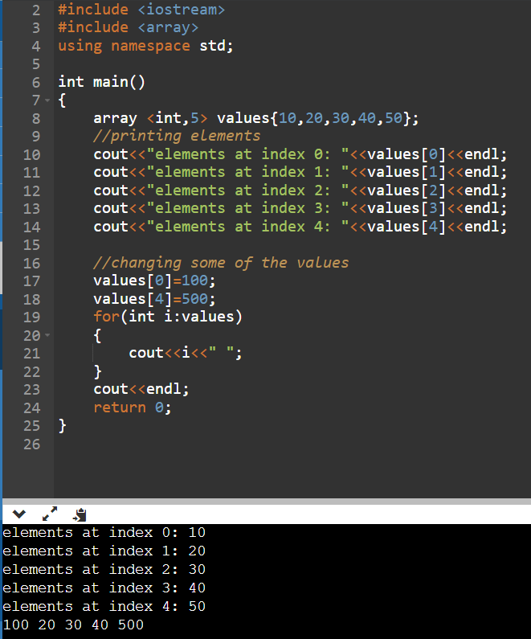

**Question -2 Using STL Array returns the total number of elements in the array.**

**Ans.**

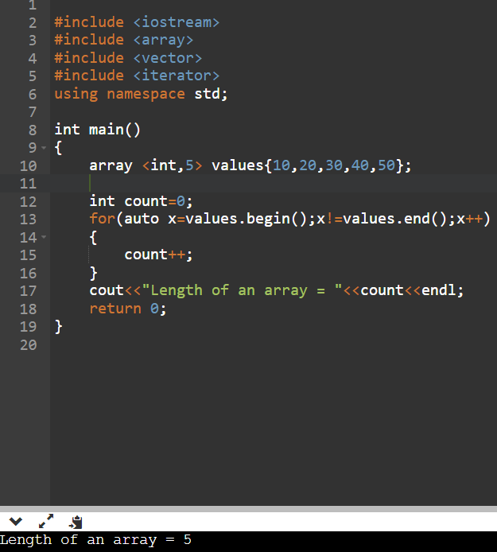

**Question -3 Find the first and last element using the STL array.**

**Ans.**

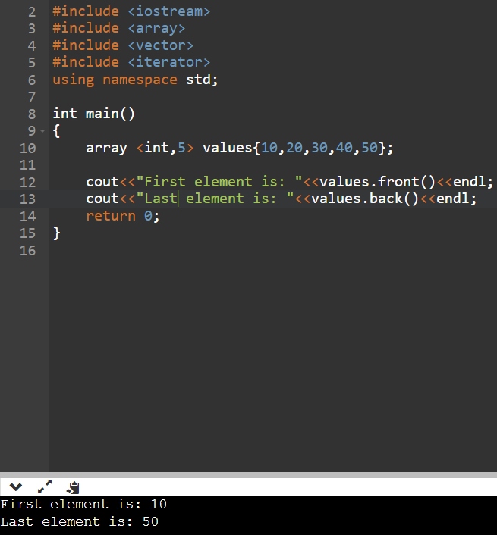

**Question – 4 Returns the element from the given index using the STL array.**

**Ans.**

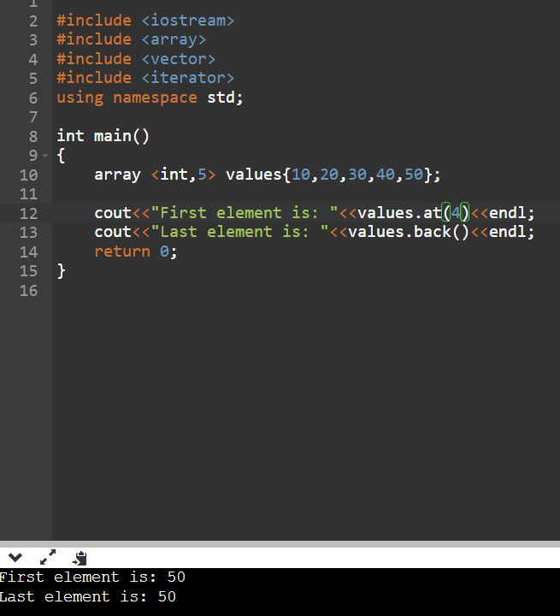

**Question – 5 C++ STL program to demonstrate example of array::rbegin() and array::rend() functions.**

**Ans.**

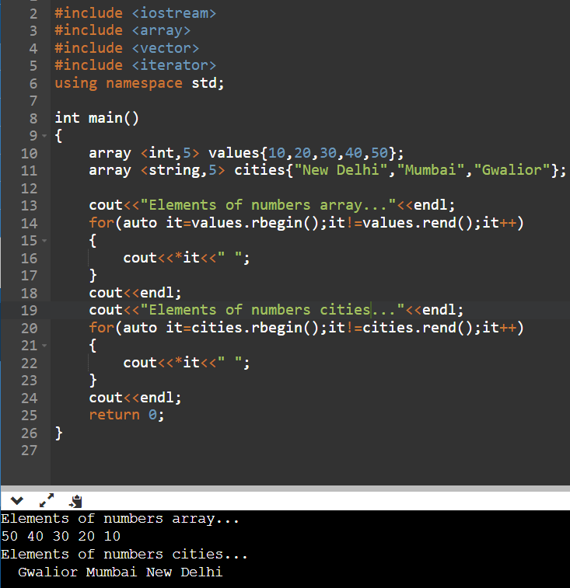

**Question – 6 Using STL to check whether an array is empty or not.**

**Ans.**

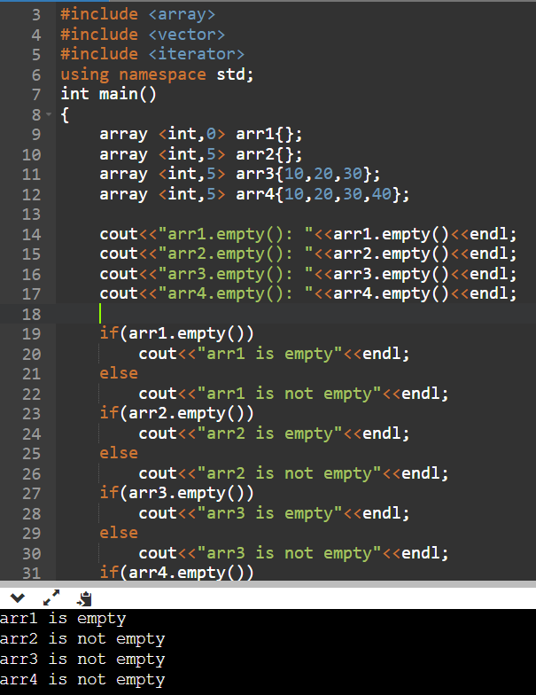

**Question – 7 Sort an array in ascending order using sort() function in C++ STL.**

**Ans.**

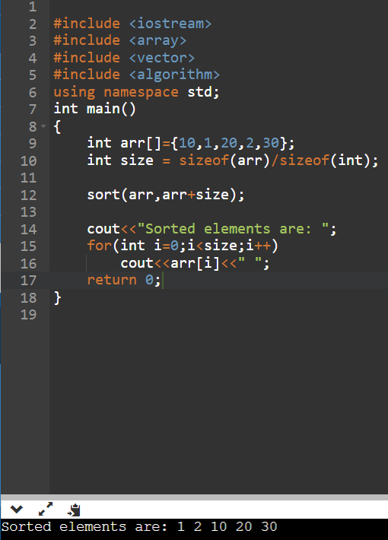

**Question – 8 Sort an array in descending order using sort() function in C++ STL.**

**Ans.**

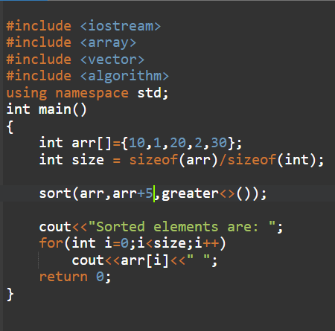

**Question – 9 C++ program to find the integers which come an odd number of times in an array using C++ STL.**

**Ans.**

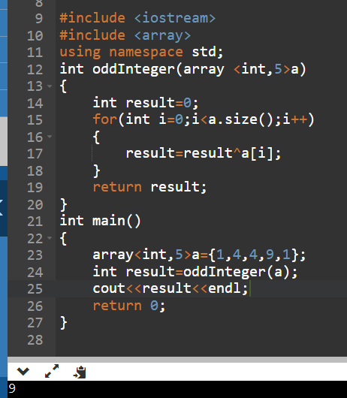

**Question – 10 Given an integer array nums , return an array answer such that answer[i] is equal to the product of all the elements of nums except nums[i] .**

**Ans.**

